Friction Stir Welding Simulation Lab

Friction Stir Welding is a joining process that plasticizes and stirs adjacent metal layers together. 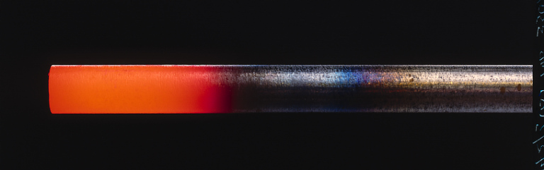This is accomplished by rotating a shaft with a specialized bit that creates a uniform stir zone. It is desirable to maintain the bottom tip of the rotating shaft at a specified temperature, especially during the startup and initial traverse of the weld. At steady state operating conditions the top of the shaft is cooled as the friction stir process generates heat.

You’ve been asked to consider ways to help the process get to steady-state conditions faster from room temperature conditions. One idea is to preheat the top of the rod so that the bottom tip is closer to the desired operating temperature upon startup. Once the welding begins, the top of the shaft is again cooled. Your task is to control a rod that is initially at room temperature and must be heated at the top of the rod to reach and maintain a temperature at the bottom end of the rod. The desired bottom tip temperature is 400°C. The rod is stationary (not yet rotating) as it is prepared to make the initial plunge to begin the weld. You should consider radiative, convective, and conductive heat transfer effects in generating a model. It is desired to have a controller that can attain the desired temperature within 2 minutes without melting any portion of the rod. The rod is made of steel and has a diameter of 3 cm and a length of 10 cm.

Helpful References and Resources

<http://en.wikipedia.org/wiki/Friction_stir_welding>

<http://youtu.be/rim0wJxZ-O8>

<http://liu.diva-portal.org/smash/record.jsf?pid=diva2:535544&rvn=4>